Day 7
Task 1:
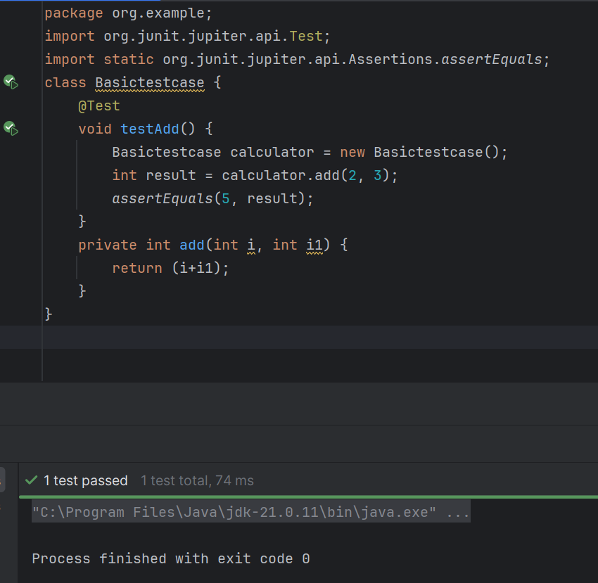
Task 2:
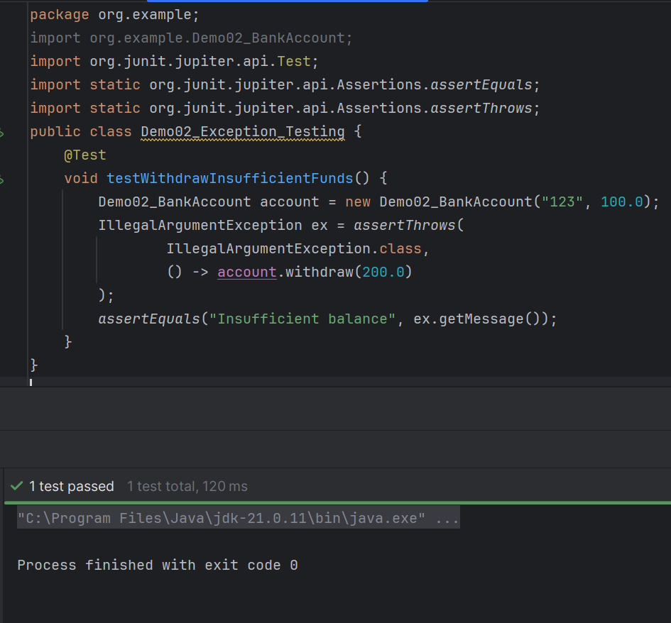
Task 3:
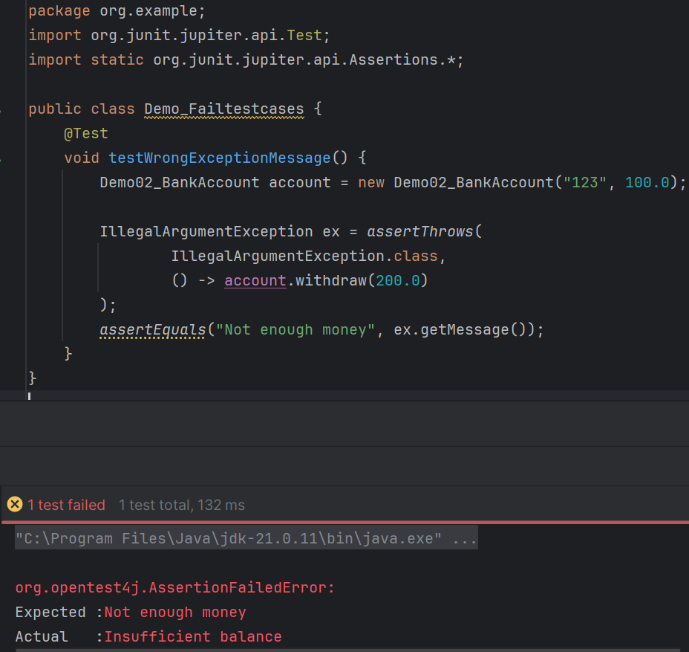
Task 4:
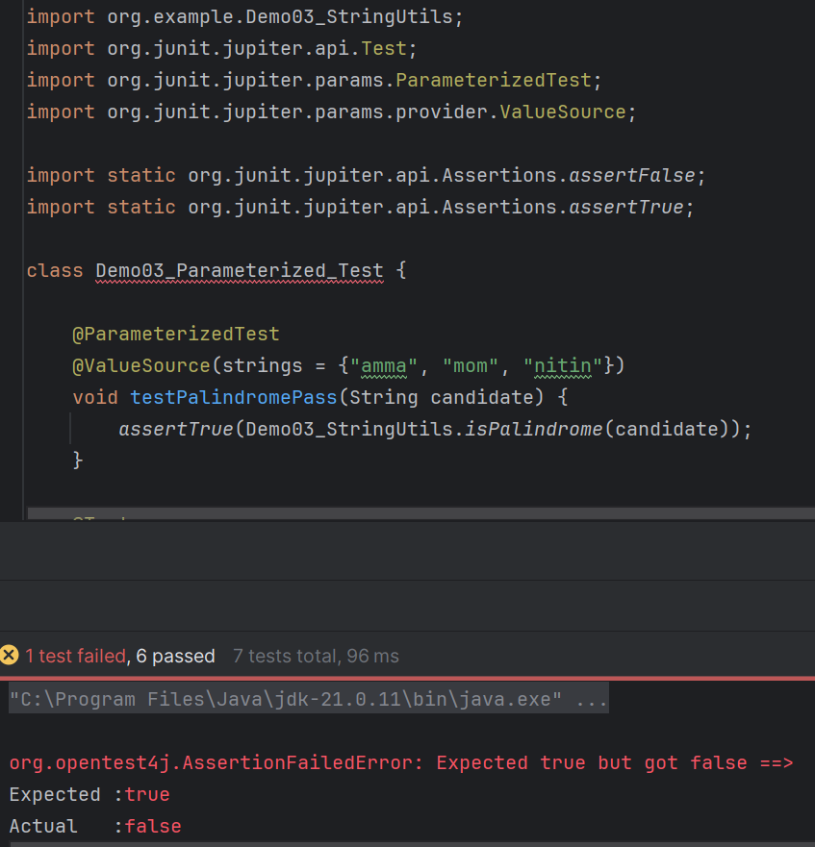
Task 5:
In JUnit, a lifecycle hook is a method that runs automatically at a specific point during the execution of tests.
Task 6:
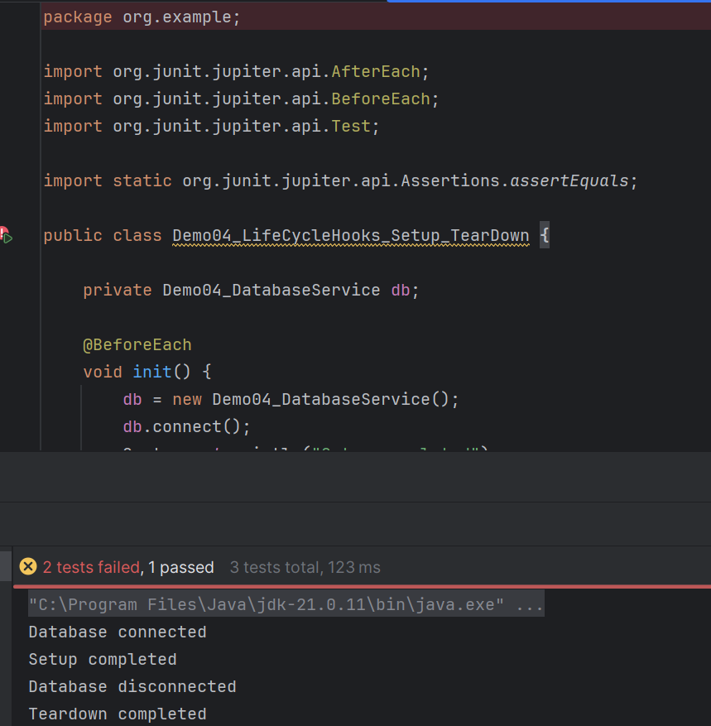
Task 7:
Assertions are methods used in JUnit tests to verify that the actual result of a program matches the expected result. If the assertion condition is true, the test passes. If it is false, the test fails.
Basic syntax - assert Method (expected, actual);

Task 8:
Time test performance means checking how much time a test method takes to execute. It helps ensure that your application code or service responds within an acceptable time limit.
In JUnit 5, we use the (@Timeout) annotation to test performance by setting a maximum execution time.

Task 9:
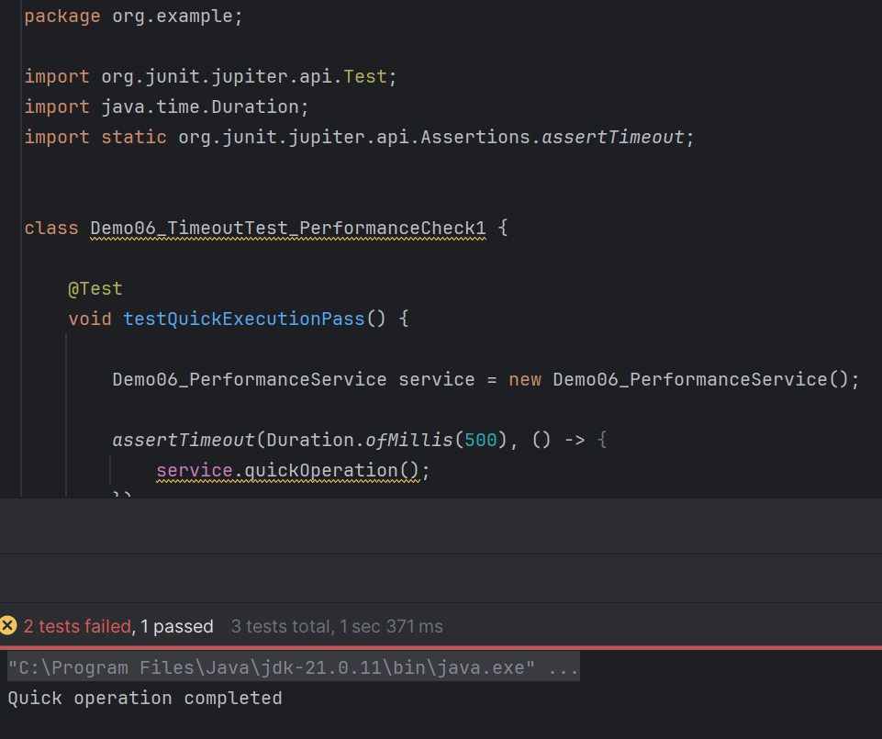

Task 10:
- Basic Test (@Test) – Used to test a single method or functionality.
- Parameterized Test (@ParameterizedTest) – Used to execute the same test multiple times with different input values.
- Repeated Test (@RepeatedTest) – Used to run the same test repeatedly for a specified number of times.
- Lifecycle Hooks (@BeforeEach, @AfterEach, @BeforeAll, @AfterAll) – Used to perform setup before tests and cleanup after tests.
- Timeout (Performance) Test (assert Timeout(), @Timeout) – Used to verify that a method completes execution within a specified time limit.
- Exception Test (assert Throws()) – Used to verify that a method throws the expected exception.

Task 11:
JVM (Java Virtual Machine) is a part of the Java Runtime Environment (JRE). It is responsible for loading, verifying, and executing Java bytecode, making Java programs platform-independent

Task 12:
An enum (enumeration) in Java is a special type used to define a fixed set of constant values. Enums make code more readable, safer, and easier to maintain.

Task 13:
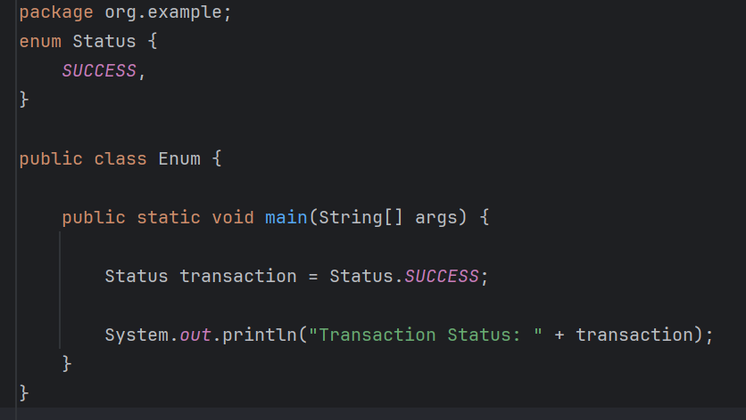
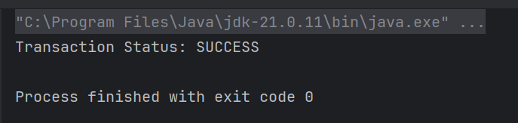

Task 14:
